**Hotel Website Diary**

11th October 2015 – Myself and James first get together to discuss plan of action. In our meeting we looked at different hotel websites for influential purposes and planned out the layout of our content. By doing all of this we drew up our first ideas for our website looking at the possibilities.

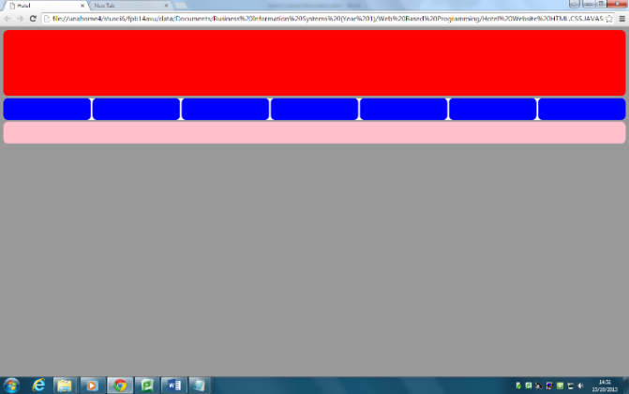15th October 2015 – First implementation of the layout is started with creation of the header, navigation bar and footer. All aspects are currently colour coded to represent the different sections.

16th October 2015 – All layout creation for the content has been complete with implementation of the CSS with an understanding from myself and James of how it’s going to be laid out

18th October 2015 – Content has been started by me and James for all of our subheadings of our website.

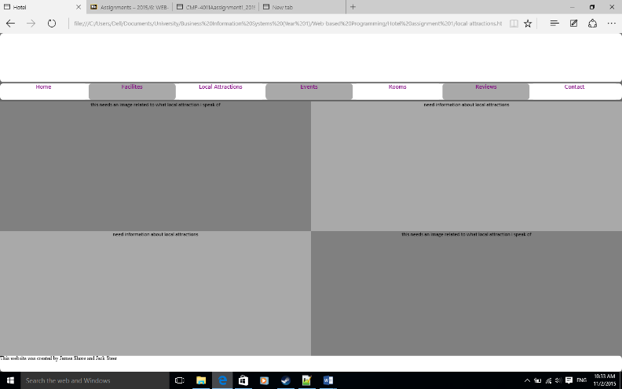19th Ocober 2015 – All subheadings with realtive URL’s are all working allowing the user to navigate to different pages within the website. Also div’s within the content of the website is complete to show the main layout of the website with more appropriate coloors are used.

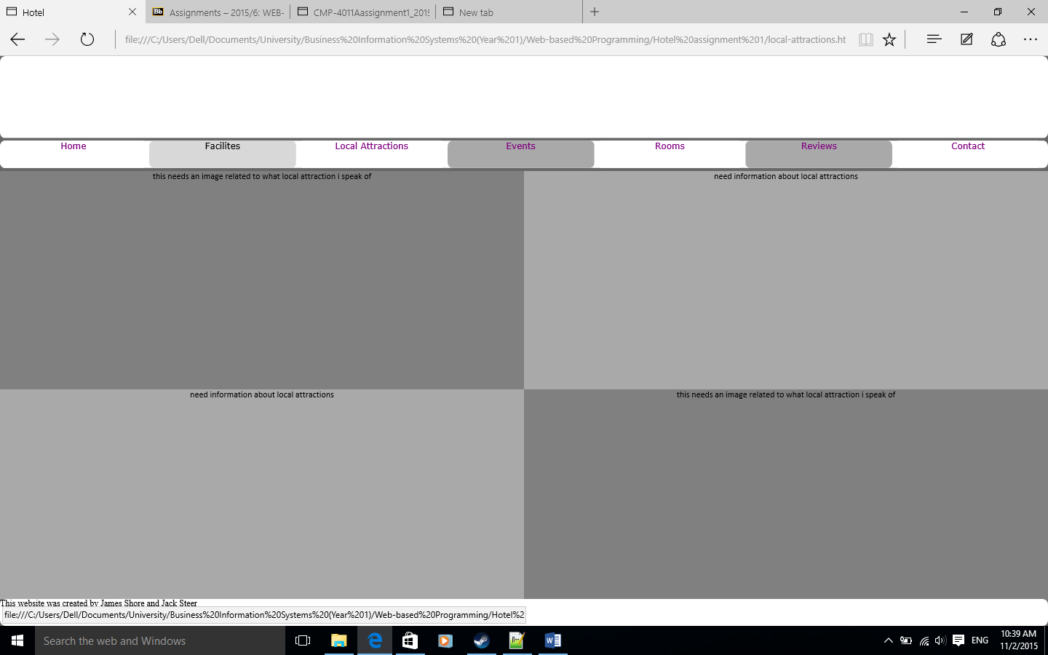21st October 2015 – Transition elements used so as the user has the cursor over one of the many subheadings, the system will react to show this.

23rd October 2015 – Contact page layout/content complete with a separate CSS created.

25th October 2015 – All content and pictures are added in too all the pages. Content was gathered by me and James and then concaterenated together.

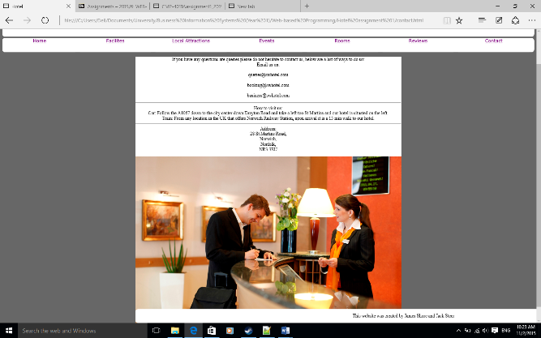28th October 2015 – Javascript gallery is fully complete allowing users to be able to navigate through a range of images.

30th October 2015 – Complete change of the color scheme for our website has been implemented using brighter more vibrant colors. Menus and content CSS changed to make it more centered.

3rd November 2015 – Adding the remaining features to our website which include thumbnails and adding/creating a logo.

